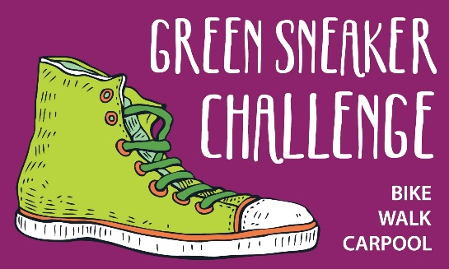

Joe Luis November 20, 2017
Santa Rosa Entertainment Group
816 4th St.
Santa Rosa, CA

Dear Joe,
Safe Routes to Schools is hosting a contest called the Green Sneaker Challenge in April-May of 2018 in efforts to increase the numbers of students walking and biking to school. Our program helps to reduce traffic and make our streets safer while promoting eco-friendly transportation alternatives in Sonoma County. At the end of the Green Sneaker Challenge, students will turn in their stamped backpack cards to become eligible to win a raffle prize.

Would you consider donating movie tickets to distribute to participating sites as a raffle prize?
We are seeking raffle prizes to distribute to participating sites, and would love to distribute a pair of movie tickets to as many participating sites as are feasible for you to donate to. Donors like you help students realize that our local community support their actions to make a difference. Safe Routes to Schools is currently working with 60 schools and over 20,000 students throughout Sonoma County with a goal of reducing Sonoma County’s carbon footprint and improving health through everyday physical activity. The breakdown of participating site by jurisdiction is: Santa Rosa (27), Petaluma (12), Sebastopol & West County (8), Windsor (3), Rohnert Park (3), Healdsburg (3), Cloverdale (2), and Sonoma (2).

All donations are fully tax-deductible. Safe Routes to Schools is a program of the Sonoma
County Transportation Authority and implemented by the Sonoma County Bicycle Coalition, a
501(c)(3), id#68-0467330. Additionally, we will recognize your business in the beneficiary site’s local school newsletter and in Safe Routes to Schools’ digital newsletter that reaches thousands in Sonoma County.

Thank you for your consideration and generosity.
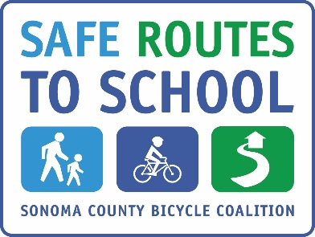
Sincerely,
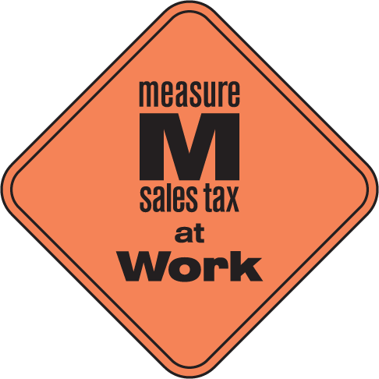
Tina Panza
Director, Education & Safe Routes to School
Sonoma County Bicycle Coalition
750 Mendocino Ave, Suite 6
Santa Rosa, CA 95404
saferoutes@bikesonoma.org
www.sonomasaferoutes.org

