MC900365904[1]MC900361104[1]**International**

**Walk & Roll**



**to School Day**

**Get out your walking shoes & bike helmets &**

**Join us for this fun, healthy event!**

**Wed Oct 9**

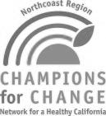 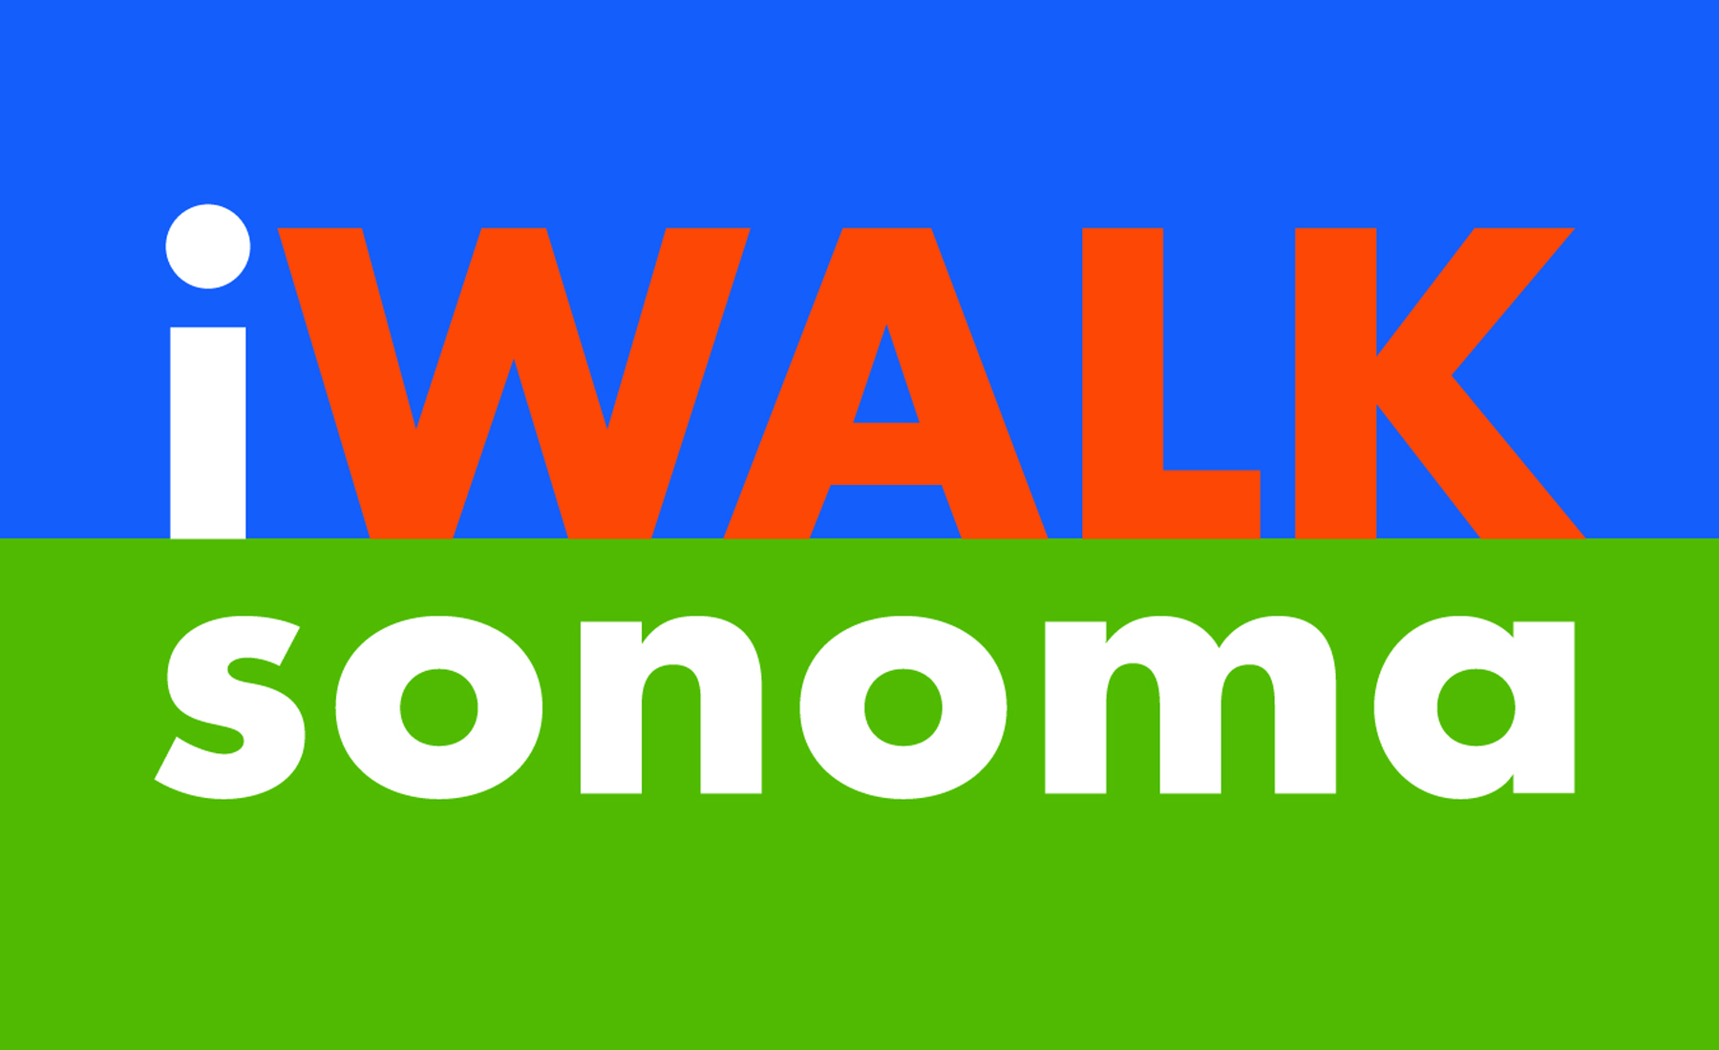  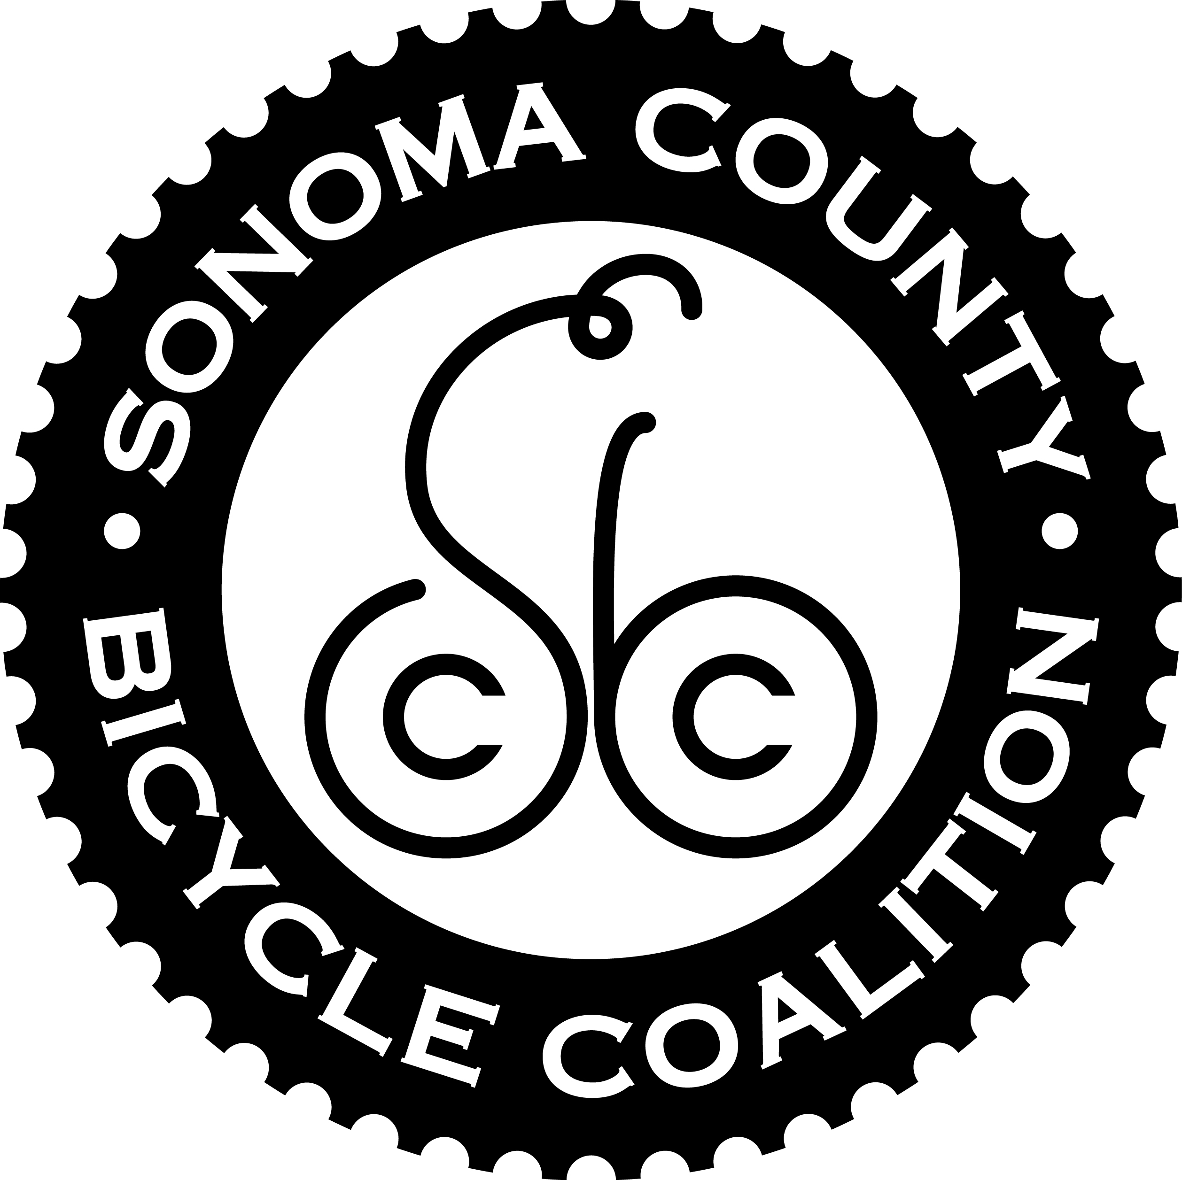 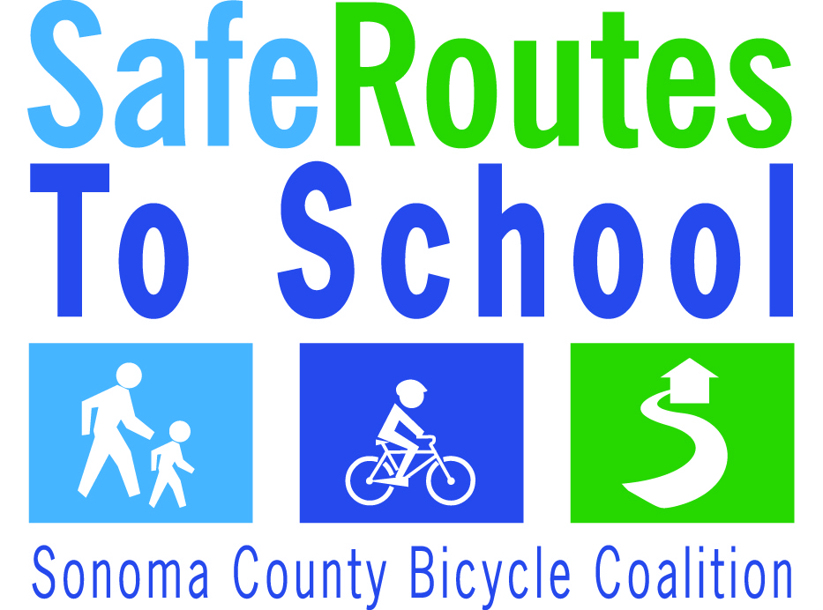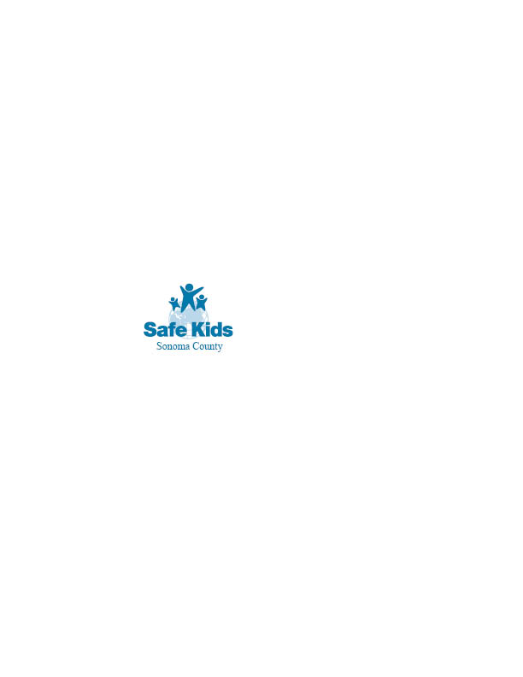 

*International Walk and Roll to School Day is brought to you by the Sonoma County Safe Routes to School Program*