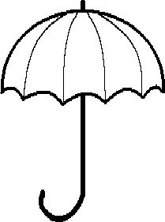MC900365904[1]MC900361104[1]**Walk & Roll**

**to School Day!**

**Celebrate the New Year by walking or rolling to school on (insert date here)!**

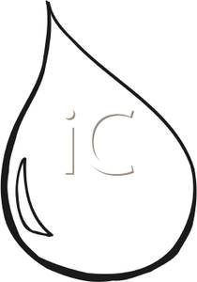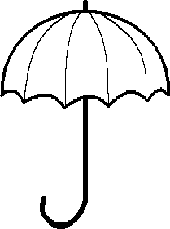

***Walk/Roll Light Rain or Shine!***

* **Add bullet about what site is doing**
* **2nd bullet about what site is doing**

**Wednesday**

January 5th

& Every ___ Wednesday of the month!

 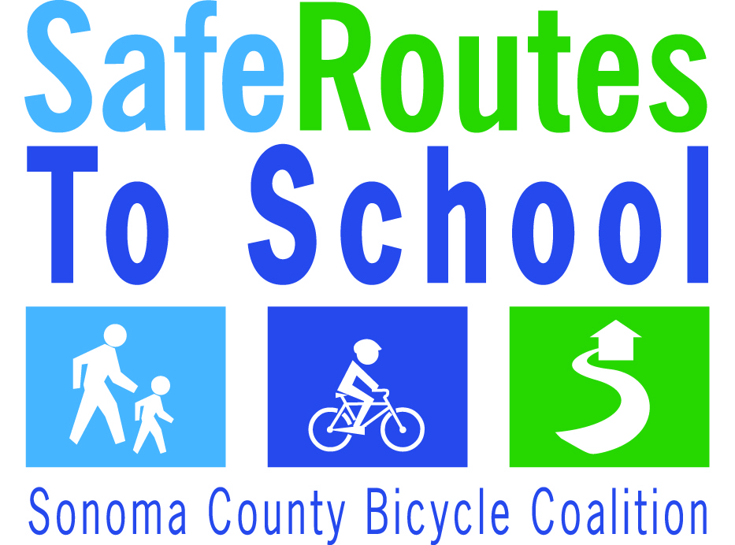 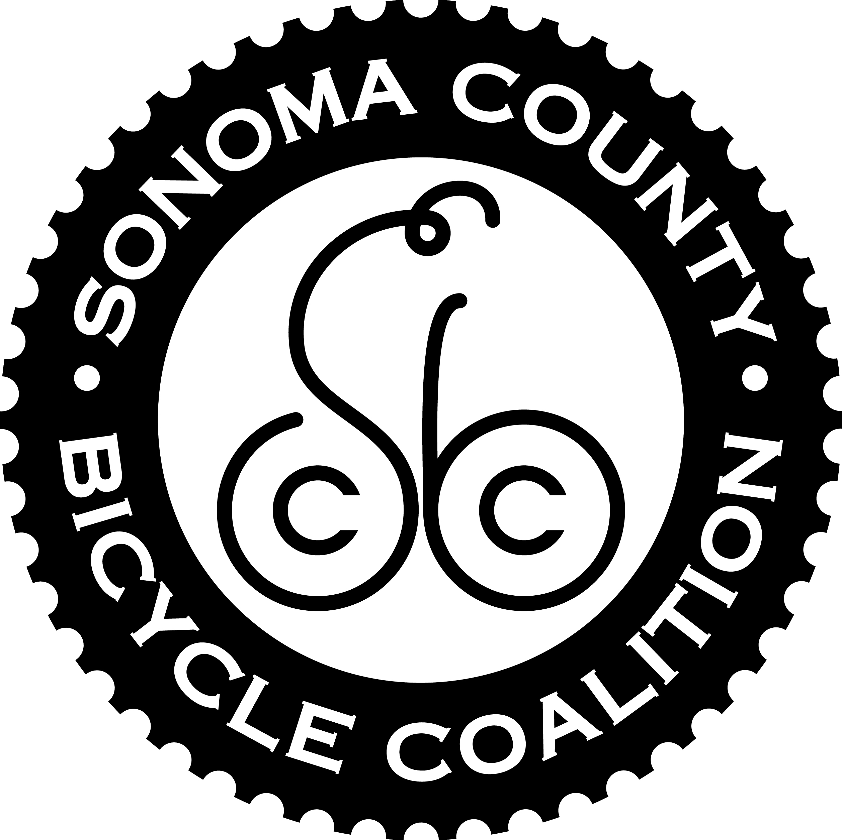

Walk and Roll to School Days are brought to you by the Sonoma County Safe Routes to School Program. *Funding for this project was provided by MTC’s Congestion Mitigation and Air Quality (CMAQ) Program in partnership with Sonoma County Departments of Transportation, Public Works and Health Services, and the Sonoma County Bicycle Coalition.*

**MC900361104[1]MC900365904[1]¡Día para  
Caminar & Rodar  
a la Escuela!**

**¡Celebrar el Año Nuevo caminado y Rodando**



**a la escuela los días**

**__ y __ de enero**

***¡Caminar/Rodar Lluvia Ligera o Sol!***

* **Add bullet about what site is doing**
* **2nd bullet about what site is doing**

**Miércoles  
__ de enero**

**& ¡el ­­­____ miércoles de cada mes!**

  

El Programa de Rutas Escolares Seguras del Condado de Sonoma le presenta el Día para Caminar y Rodar a la Escuela. *Funding for this project was provided by MTC’s Congestion Mitigation and Air Quality (CMAQ) Program in partnership with Sonoma County Departments of Transportation, Public Works and Health Services, and the Sonoma County Bicycle Coalition.*