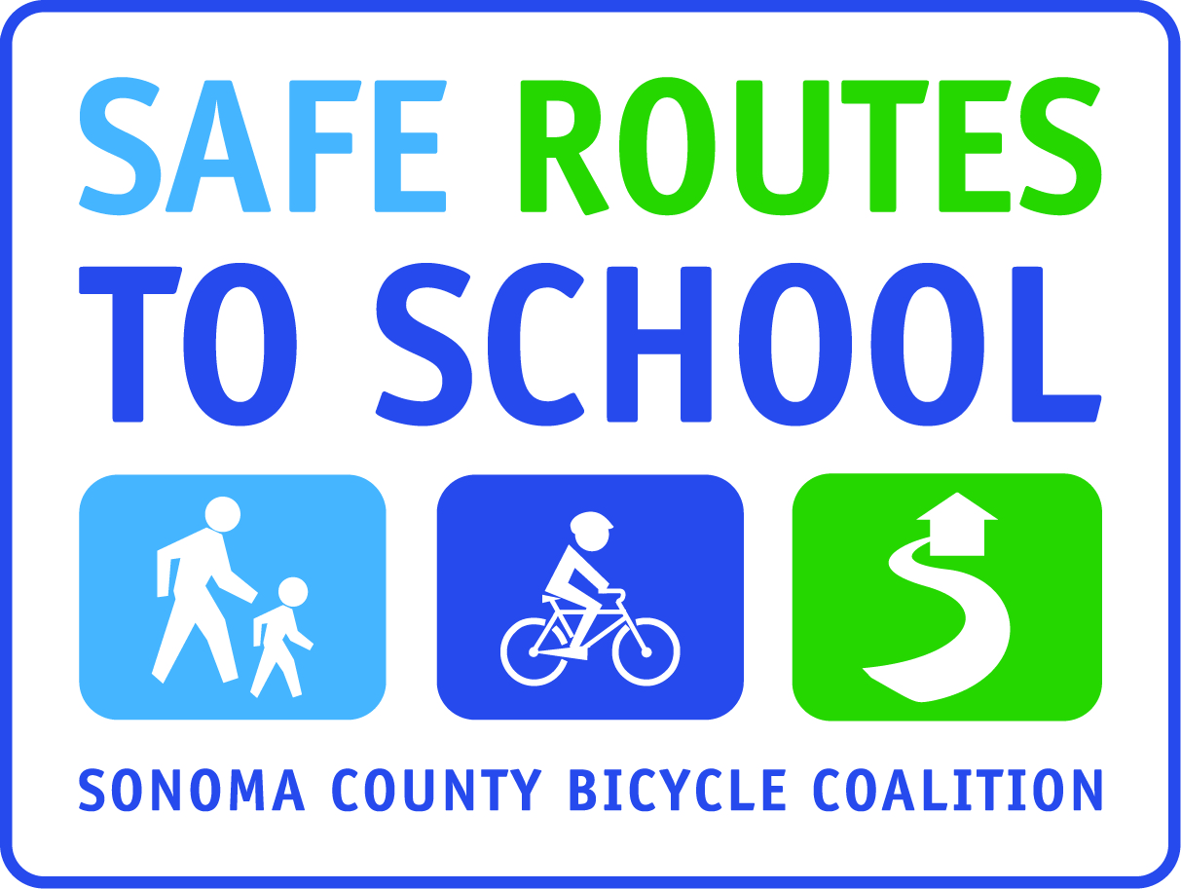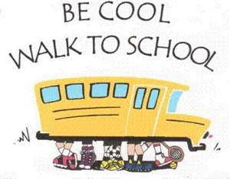
WALKING (or bicycling) SCHOOL BUSES

Families - Let’s start a healthy, active transportation movement by walking (or bicycling) to school together at least once a week!
What is a Walking School Bus? A Walking School Bus is a group of children walking to school with one or more adults (if bicycling, it’s called a bicycling school bus).
Why should I form or join a walking school bus?
- Enable kids who may not be able to walk/bicycle to school to do so safely.
- Share responsibility and build connections with other parents and children
- Reduce congestion and air pollution
- Spend quality, healthy time with children on the way to/from school
- Increase eyes and adult presence on the street and enhance personal safety
Does Our Elementary School have any Walking School Buses?
Yes – we know parents are walking and bicycling with children already, we just don’t know who you are! Please contact your principal or return the Walking School Bus enrollment form (on reverse) if you would like to start a walking school bus route OR are already leading a walking school bus and are willing to share that information with the school community and enable other parents and/or children to join you. The more we as a community share, the more we as a community can participate.

What information will be shared about each Walking School Bus?
Walking School Bus scenario #1
Leader: any parent currently walking or bicycling to school & willing to have other parents and/or children join him/her!
Meeting point: wherever that parent chooses to meet (at your home, on a corner near your home, etc)
Contact: parent name, phone and/or email
Departure Time: whatever time and day(s) of week the parent decides
Route: typically displayed on a map

Walking School Bus scenario #2
Leader: any parent interested in being stationed at a designated meeting point even if they do not currently walk or bicycle to school, and willing to be at that meeting point at least once a week at a designated time.
Meeting point: either a point determined by the SRTS school team (such as a local park), or by the interested parent
Contact: parent name, phone and/or email
Departure Time: whatever time and day(s) of week the leader or SRTS team decides
Route: typically displayed on a map

Note: Parents either need to accompany kids OR check with the Walking School bus leader in advance to ensure that there is enough adult supervision to allow your child to join.

