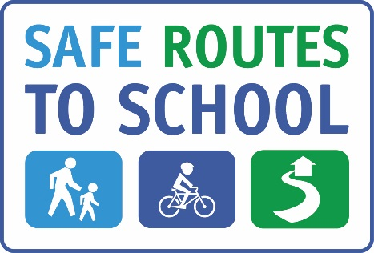

JOIN OUR PARENT TEAM!

**Help us create a walking and biking culture!**

**Can YOU volunteer for a few hours this 2024-25 school year?**

**Opportunities include:**

* Assist with our Walk & Roll program

* Lead a Walking School Bus or Bike Train

* Become involved with improving infrastructure and safety

**________NAME___________________EMAIL________________________PHONE______________**

_________________________________________________________________________________

_________________________________________________________________________________

_________________________________________________________________________________

_________________________________________________________________________________

_________________________________________________________________________________

_________________________________________________________________________________

_________________________________________________________________________________

_________________________________________________________________________________

*This project is supported by the Metropolitan Transportation Commission’s One Bay Area Grant Program and Measure M/Go Sonoma Transportation Tax.*

¡UNASE A NUESTRO EQUIPO DE PADRES DE FAMILIA!

**¡Ayúdenos a crear una cultura de caminar y viajar en bici!**

**¿Puede ser voluntario por algunas cuantas horas este año escolar 2024-25?**

**Las oportunidades incluyen:**

* Ayude con nuestro programa Walk & Roll

* Dirigir un autobús escolar a pie o un tren en bicicleta

* Involucrarse en la mejora de la infraestructura y la seguridad.

**NOMBRE_________________CORREO ELECTRONICO ____________NO. DE TELÉFONO__________**

_________________________________________________________________________________

_________________________________________________________________________________

_________________________________________________________________________________

_________________________________________________________________________________

_________________________________________________________________________________

_________________________________________________________________________________

_________________________________________________________________________________

_________________________________________________________________________________

_________________________________________________________________________________

*Este proyecto recibe el apoyo del programa de concesiones One Bay Area de la Comisión Metropolitana de Transportion y al transporte de la Medida M/Go Sonoma*