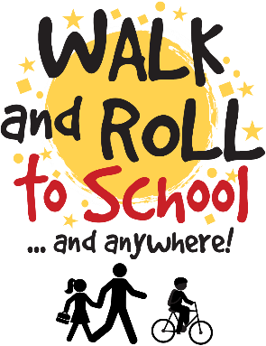

WALK & ROLL EVENTS & CHALLENGES
2021-2022

Walk & Roll to School on our monthly Walk & Roll Day and visit our welcome table! Or, take our Walk & Roll Survey on any day of the Walk & Roll week each month!
Month | Theme & Challenge | Walk/Roll Week | Walk/Roll Day (event day with welcome table set up)
September | Walk & Roll Back to School Route Map | n/a (all month) | n/a
October | International Walk & Roll Safety BINGO | Oct 4th-8th | Wednesday, Oct 6th
November | Walk & Roll Gratitude Tracker | Nov 1st-5th | Wednesday Nov 3rd
December | Walk & Roll for Wheels Scavenger Hunt | Dec 6th-10th | Wednesday Dec 8th
January | Idle Free Pledge | n/a (all month) | n/a
February | Walk & Roll for our HeARTS Art contest | Jan 31st-Feb 4th | Wednesday Feb 2nd
March | Green Sneaker Challenge | Feb 28th-March 4th | Wednesday March 2nd
April | Walk & Roll for the Earth Challenge | April 4th-8th | Wednesday April 6th
May | Bike2It! Challenge | May 2nd-6th | Wednesday May 4th
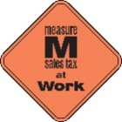
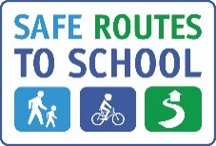
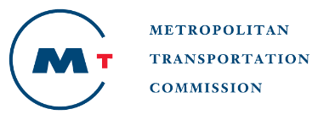
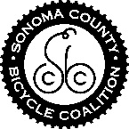

This project is supported by the Metropolitan Transportation Commission’s One Bay Area Grant Program and the Measure M Transportation Tax

