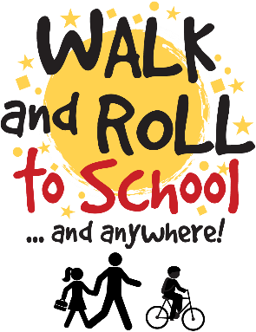

WALK & ROLL EVENTS & CHALLENGES
2022-2023

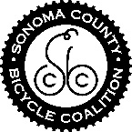
Walk & Roll to School on our monthly Walk & Roll Day and visit our welcome table! Or, take our Walk & Roll Survey on any day of the Walk & Roll week each month!
Month | Theme & Challenge | Walk/Roll Week | Walk/Roll Day (event day with welcome table set up)
September | Walk & Roll Back to School Route Map | n/a (all month) | n/a
October | International Walk & Roll 20th Anniversary Tracking Sheet | Oct 3rd-7th | Wednesday, Oct 5th
November | Ruby Bridges Walk to School | Nov 14th-18th | Wednesday Nov 16th
December | Walk & Roll for Wheels Scavenger Hunt | Dec 5th-9th | Wednesday Dec 7th
January | Idle Free Pledge | n/a (all month) | n/a
February | Walk & Roll for our HeARTS Art contest | Jan 30th-Feb 3rd | Wednesday Feb 1st
March | March for Miles Challenge | Feb 27th-March 3rd | Wednesday March 1st
April | Walk & Roll for the Earth Challenge | April 3rd-7th | Wednesday April 5th
May | Bike to School Day | May 1st-5th | Wednesday May 3rd
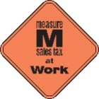
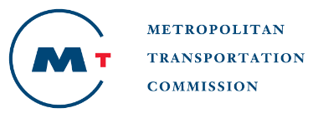
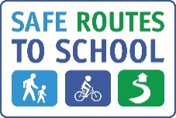

This project is supported by the Metropolitan Transportation Commission’s One Bay Area Grant Program and the Measure M Transportation Tax

